TEACHER RESOURCE 16

The 7 Principles of Graphic Communication
A Differentiated GCSE and A Level Classroom Pack

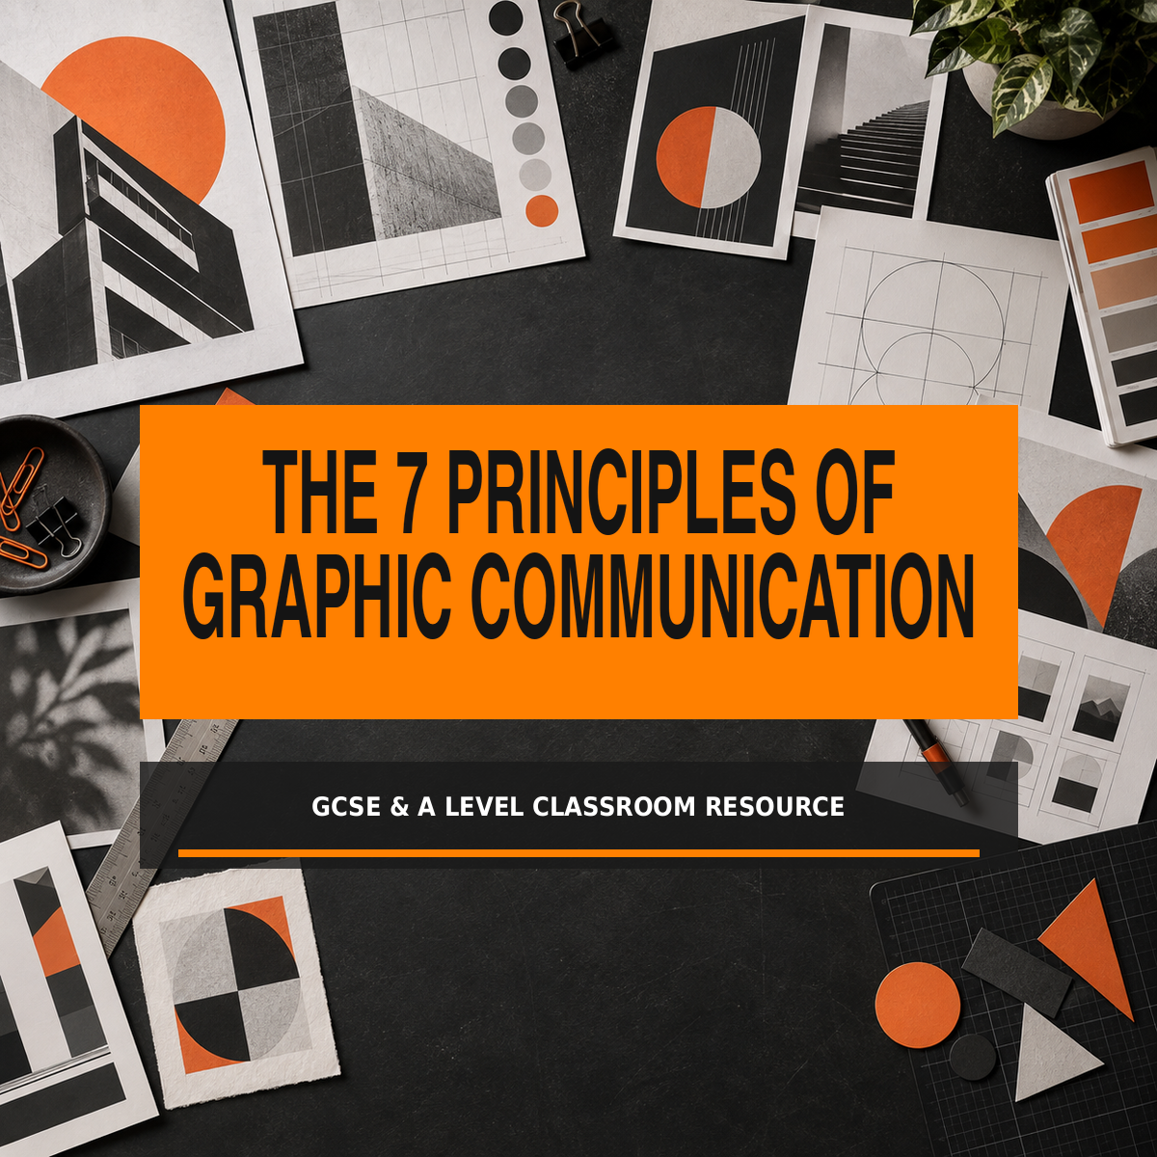
An 18-page differentiated resource with original illustrative teaching exemplars, activities and review sheets.
Editable Word document and print-ready PDF

How to use this pack

This pack helps students recognise and apply seven established principles of graphic design: balance, alignment, hierarchy, contrast, repetition, proximity and white space. Each principle is introduced through an original illustrative teaching exemplar, followed by a focused GCSE task and a more independent A Level extension.

Suggested teaching sequence
1. Introduce the seven principles with the quick-reference page.
2. Display one exemplar at a time and ask students to identify visual evidence before revealing the principle.
3. Choose the GCSE task or A Level extension appropriate to the class.
4. Use the comparison and redesign pages to show that several principles normally work together.
5. Finish with the design audit and require students to explain how their choices improve communication.

Learning outcomes
- Identify each principle in a poster, page, logo, campaign or digital layout.
- Explain how visual decisions control order, emphasis and clarity.
- Use accurate subject vocabulary and refer to specific evidence.
- Improve a weak layout by changing relationships between elements.
- Apply and justify selected principles in personal Graphic Communication work.
IMPORTANT All designs in this pack are original illustrative teaching exemplars. They are not real student submissions, commercial client work or examination-board exemplars.

The seven principles at a glance

PRINCIPLE | WHAT IT DOES | QUESTION TO ASK
BALANCE | Distributes visual weight to create stability or deliberate tension. | Does one area feel heavier than another?
ALIGNMENT | Lines elements up so they appear connected and ordered. | Which edges, centres or guides connect the elements?
HIERARCHY | Creates an order of importance through scale, weight and placement. | What do you read first, second and third?
CONTRAST | Uses visible difference to create emphasis and legibility. | Where are the strongest differences?
REPETITION | Repeats visual choices to create rhythm and identity. | Which colours, fonts, shapes or structures return?
PROXIMITY | Groups related information and separates unrelated information. | Which items belong together, and how can you tell?
WHITE SPACE | Uses empty or negative space to give content room and focus. | Where has space been deliberately protected?

A principle is not a rule that produces one correct answer
Effective designers select and combine principles according to purpose, audience and format. A layout may be asymmetrical but still balanced; tightly grouped but not cramped; spacious but not empty. Students should explain the effect of a decision rather than simply name a feature.
GCSE ROUTE Identify the principle and point to one clear piece of visual evidence.
A LEVEL ROUTE Judge how successfully principles work together, consider alternatives and justify refinements in relation to purpose and audience.

Principle 1: Balance

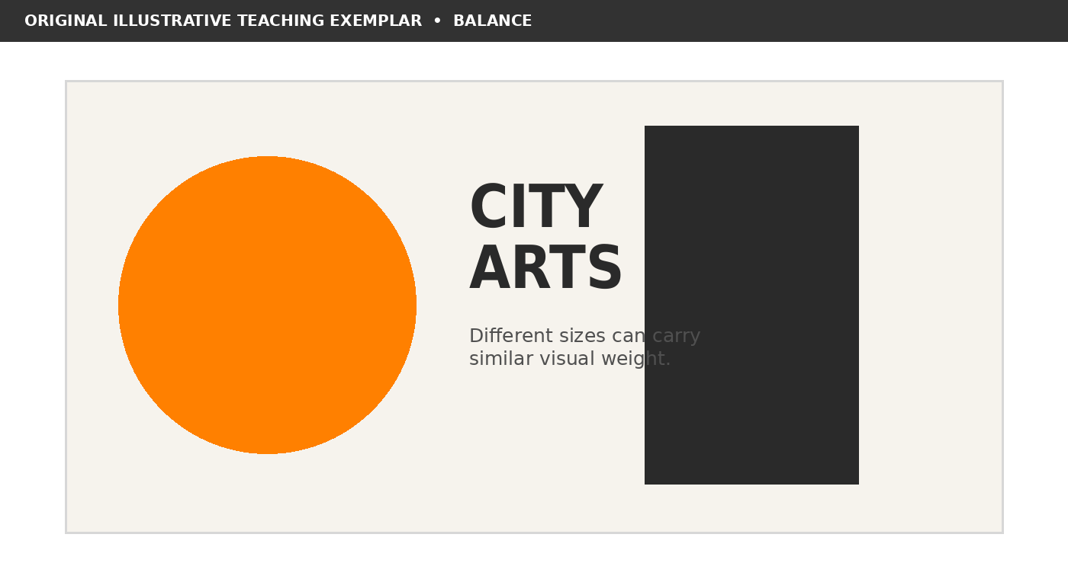
Original illustrative teaching exemplar for balance; not real student or commercial client work.

What it means
Visual weight is distributed evenly or intentionally. Symmetry can feel stable and formal; asymmetry can feel active while remaining controlled.

What to notice
- Which shape, image or text block appears visually heaviest?
- Would the layout still feel stable if one element were removed?
GCSE TASK Annotate the exemplar with two arrows. Name one visible use of balance and explain how it helps the viewer understand the design. Then sketch one alternative arrangement in the space below.
Visual evidence:
Effect on the viewer:
Alternative idea:
A LEVEL EXTENSION Evaluate whether the use of balance is appropriate for a cultural event aimed at 16- to 19-year-olds. Propose one purposeful refinement, explain the trade-off it creates and justify your decision in relation to audience and format.

Principle 2: Alignment

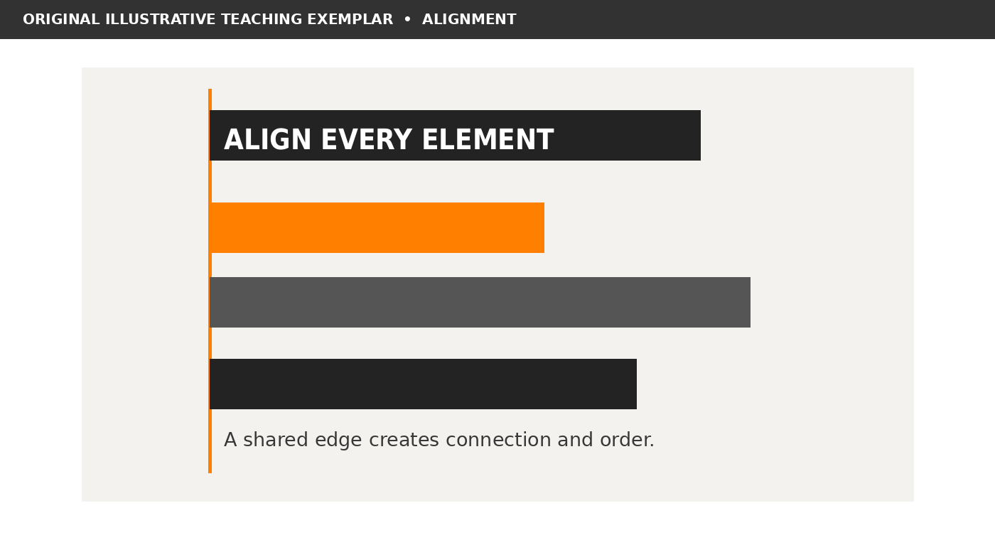
Original illustrative teaching exemplar for alignment; not real student or commercial client work.

What it means
Elements share an edge, centre or underlying guide. Alignment builds visible relationships and prevents a layout from feeling accidental.

What to notice
- Which edges or centres line up?
- Where does alignment guide the eye through the design?
GCSE TASK Annotate the exemplar with two arrows. Name one visible use of alignment and explain how it helps the viewer understand the design. Then sketch one alternative arrangement in the space below.
Visual evidence:
Effect on the viewer:
Alternative idea:
A LEVEL EXTENSION Evaluate whether the use of alignment is appropriate for a cultural event aimed at 16- to 19-year-olds. Propose one purposeful refinement, explain the trade-off it creates and justify your decision in relation to audience and format.

Principle 3: Hierarchy

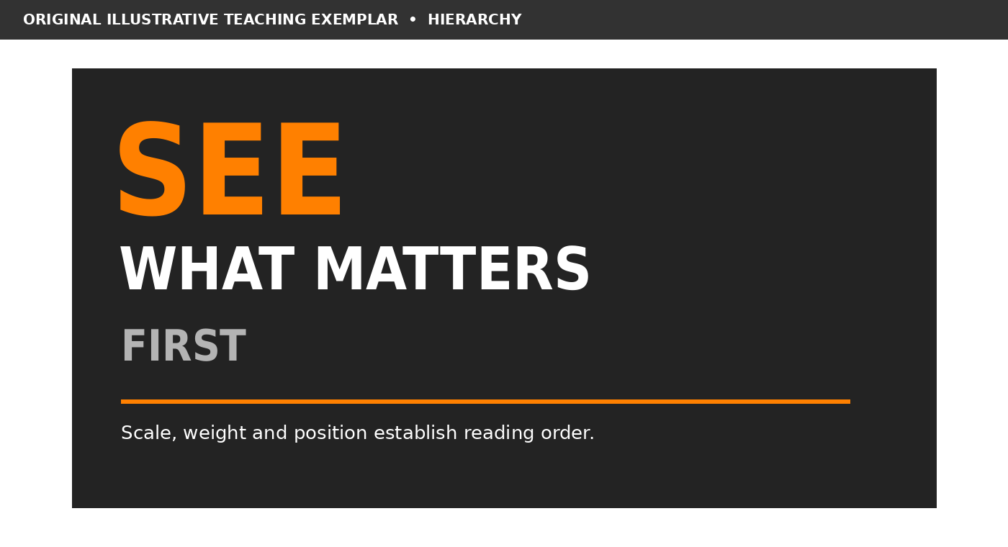
Original illustrative teaching exemplar for hierarchy; not real student or commercial client work.

What it means
Size, weight, colour and position create an order of importance. Strong hierarchy ensures the main message is understood first.

What to notice
- What is read first, second and third?
- Could the key message still be found at a distance?
GCSE TASK Annotate the exemplar with two arrows. Name one visible use of hierarchy and explain how it helps the viewer understand the design. Then sketch one alternative arrangement in the space below.
Visual evidence:
Effect on the viewer:
Alternative idea:
A LEVEL EXTENSION Evaluate whether the use of hierarchy is appropriate for a cultural event aimed at 16- to 19-year-olds. Propose one purposeful refinement, explain the trade-off it creates and justify your decision in relation to audience and format.

Principle 4: Contrast

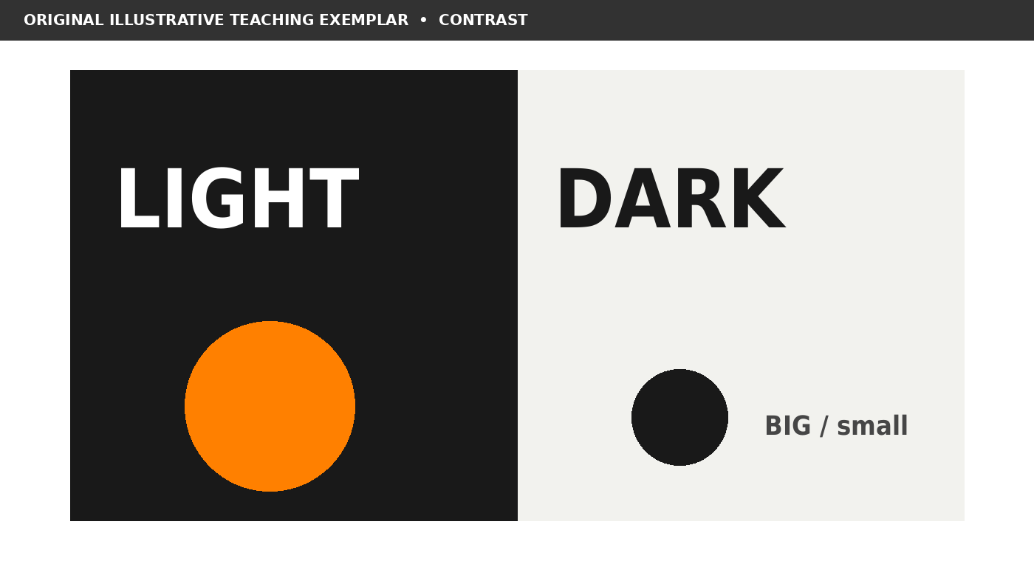
Original illustrative teaching exemplar for contrast; not real student or commercial client work.

What it means
Differences in tone, colour, scale, weight, shape or space separate information and create emphasis. Contrast should also protect legibility.

What to notice
- Where is the strongest difference?
- Does the contrast clarify meaning or merely add decoration?
GCSE TASK Annotate the exemplar with two arrows. Name one visible use of contrast and explain how it helps the viewer understand the design. Then sketch one alternative arrangement in the space below.
Visual evidence:
Effect on the viewer:
Alternative idea:
A LEVEL EXTENSION Evaluate whether the use of contrast is appropriate for a cultural event aimed at 16- to 19-year-olds. Propose one purposeful refinement, explain the trade-off it creates and justify your decision in relation to audience and format.

Principle 5: Repetition

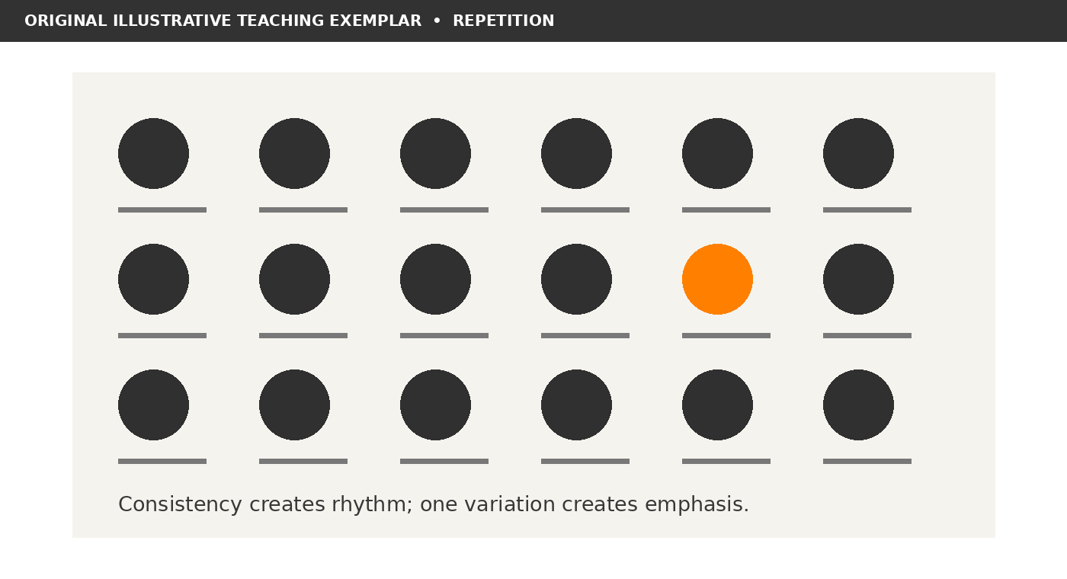
Original illustrative teaching exemplar for repetition; not real student or commercial client work.

What it means
Repeated colours, type styles, shapes or structures create rhythm, consistency and recognition. Controlled variation can then create emphasis.

What to notice
- What repeats across the layout?
- Which single variation attracts attention, and why?
GCSE TASK Annotate the exemplar with two arrows. Name one visible use of repetition and explain how it helps the viewer understand the design. Then sketch one alternative arrangement in the space below.
Visual evidence:
Effect on the viewer:
Alternative idea:
A LEVEL EXTENSION Evaluate whether the use of repetition is appropriate for a cultural event aimed at 16- to 19-year-olds. Propose one purposeful refinement, explain the trade-off it creates and justify your decision in relation to audience and format.

Principle 6: Proximity

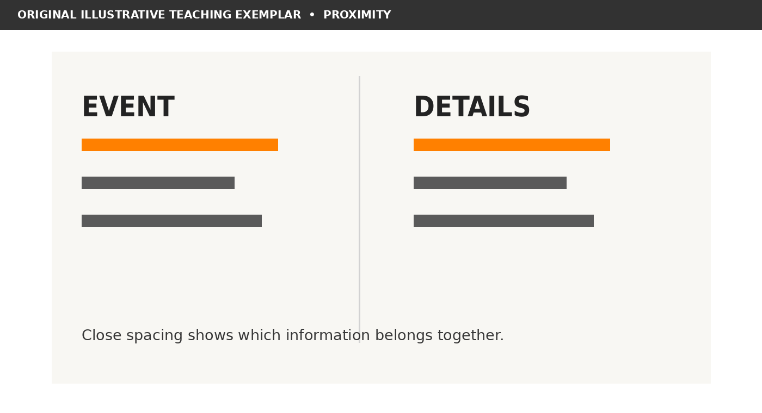
Original illustrative teaching exemplar for proximity; not real student or commercial client work.

What it means
Related elements are placed close together while unrelated groups are separated. This makes the structure of information easier to understand.

What to notice
- Which information belongs together?
- Are any items close enough to imply the wrong relationship?
GCSE TASK Annotate the exemplar with two arrows. Name one visible use of proximity and explain how it helps the viewer understand the design. Then sketch one alternative arrangement in the space below.
Visual evidence:
Effect on the viewer:
Alternative idea:
A LEVEL EXTENSION Evaluate whether the use of proximity is appropriate for a cultural event aimed at 16- to 19-year-olds. Propose one purposeful refinement, explain the trade-off it creates and justify your decision in relation to audience and format.

Principle 7: White Space

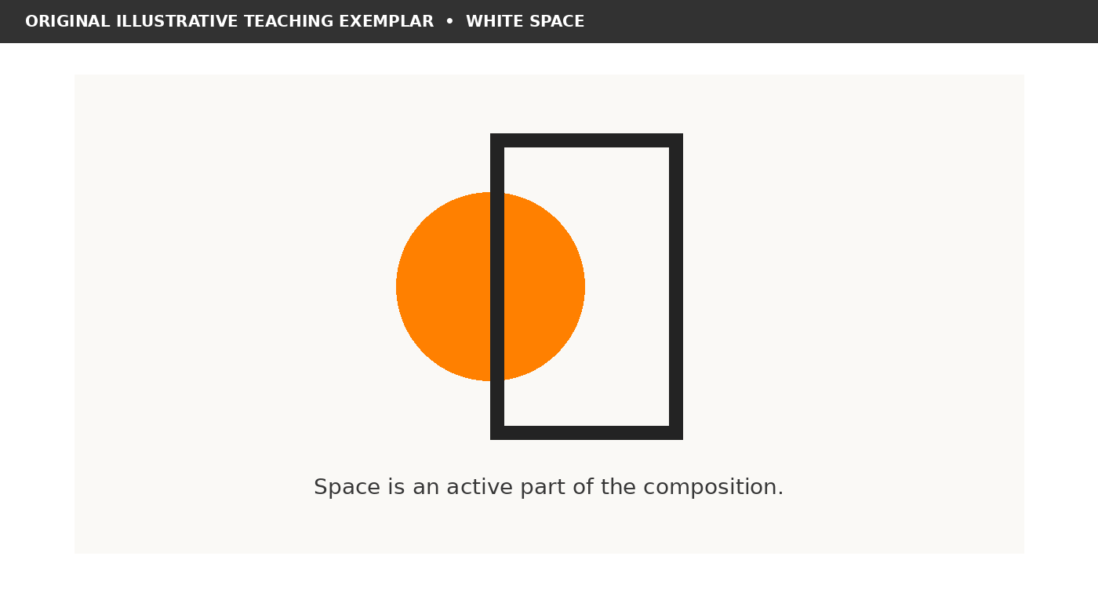
Original illustrative teaching exemplar for white space; not real student or commercial client work.

What it means
Empty or negative areas are treated as active parts of the design. Space reduces clutter, separates groups and increases focus.

What to notice
- Where can the eye pause?
- Would adding another element improve communication or weaken it?
GCSE TASK Annotate the exemplar with two arrows. Name one visible use of white space and explain how it helps the viewer understand the design. Then sketch one alternative arrangement in the space below.
Visual evidence:
Effect on the viewer:
Alternative idea:
A LEVEL EXTENSION Evaluate whether the use of white space is appropriate for a cultural event aimed at 16- to 19-year-olds. Propose one purposeful refinement, explain the trade-off it creates and justify your decision in relation to audience and format.

Identify the strongest principle

Study the seven exemplars again. More than one principle will be present, but identify the principle doing the most important communicative work in each example.
EXAMPLE | STRONGEST PRINCIPLE | VISUAL EVIDENCE | EFFECT
1
2
3
4
5
6
7

GCSE task
- Name the strongest principle in each example.
- Point to a specific shape, space, edge, colour or text relationship.
- Complete: “This helps the viewer because…”

A Level extension
- Identify a second principle that supports or competes with the first.
- Explain whether the relationship is successful for the intended audience.
- Describe one alternative design decision and the different effect it would create.
TEACHER PROMPT Accept well-supported alternatives. The aim is not to guess a hidden answer but to connect terminology to visible evidence.

How principles work together

Original illustrative teaching exemplar; not real student or commercial work.

Model analysis
- Hierarchy makes SEE the first reading point through scale and orange colour.
- Contrast separates orange, white and grey information from the charcoal ground.
- Alignment connects the left edges of the three text levels.
- White space around the main words prevents the message becoming crowded.
- The orange circle and large type create asymmetrical balance across the composition.
GCSE TASK Choose three principles and add one evidence-based annotation for each.
A LEVEL EXTENSION Rank the principles in order of importance to the communication. Defend your ranking and explain how weakening one principle would affect the others.
Most important principle and why:
A useful interaction between two principles:
A justified refinement:

Improve a weak layout

The brief: promote a local creative workshop to 16- to 19-year-olds. The draft contains the necessary information, but its structure is unclear.
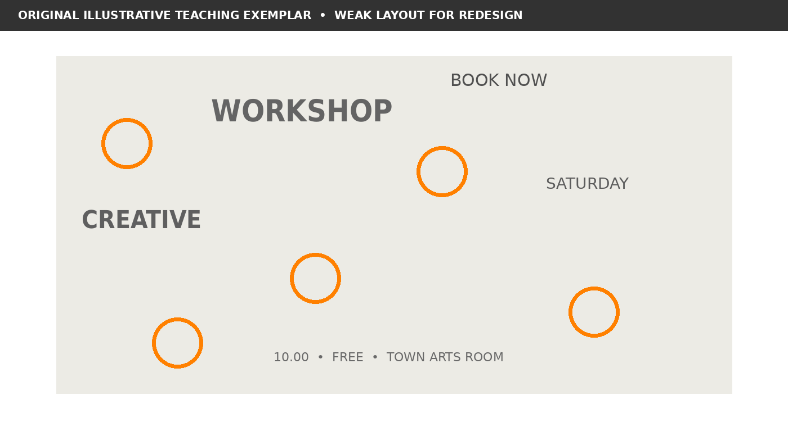
Original deliberately weak teaching exemplar; not real student or commercial client work.

Diagnose before redesigning
PROBLEM | PRINCIPLE INVOLVED | PROPOSED CHANGE
No obvious first message
Elements appear disconnected
Low tonal difference
Spacing feels accidental
GCSE TASK Redraw the layout using a clear headline, one alignment and two information groups.
A LEVEL EXTENSION Develop two contrasting solutions for different formats, then justify which better suits the audience and purpose.

GCSE design challenge

Create an A4 poster for a school or college exhibition called Make Your Mark. It must communicate the title, date, venue and a short invitation clearly.

Required process
1. Choose three principles to lead your design.
2. Produce three small thumbnail compositions before selecting one.
3. Develop the strongest thumbnail using no more than two typefaces and three colours.
4. Annotate where each selected principle appears.
5. Ask a partner to identify what they read first, second and third.
6. Refine one feature in response to the feedback.
MY SELECTED PRINCIPLE | HOW I WILL SHOW IT | WHY IT SUITS THE BRIEF
1.
2.
3.

Success criteria
- The exhibition title is the clearest message.
- Related information is grouped and aligned.
- Text remains readable and contrast is sufficient.
- Repeated visual choices make the design feel connected.
- Empty space is deliberately controlled.
- Annotations explain effects rather than only naming features.
Peer feedback - what I noticed first:
My refinement:

A Level design challenge

Develop a small visual identity and two connected outcomes for an independent exhibition titled Make Your Mark. Choose two formats, such as poster and social tile, invitation and web banner, or programme cover and wayfinding sign.

Higher-level expectations
- Define a specific audience, context and communication purpose.
- Establish a flexible grid and hierarchy that can adapt across formats.
- Explore at least two substantially different visual systems.
- Use repetition to create identity without making every outcome identical.
- Test legibility, scale, crop and white space in each format.
- Evaluate trade-offs: for example, expression versus clarity or consistency versus variation.
- Justify refinements using precise evidence from your own trials.
DESIGN DECISION | OPTION A | OPTION B | JUSTIFIED CHOICE
Grid and alignment
Hierarchy
Contrast and colour
Repeated identity element
Use of space
How the system changes across formats:
What I rejected and why:
Final judgement:

Critique and peer review

Review one completed design without beginning with personal taste. Identify the purpose, describe visible decisions and explain their effect on communication.
PRINCIPLE | EVIDENCE I CAN SEE | EFFECT ON MESSAGE OR AUDIENCE | REFINEMENT
Balance
Alignment
Hierarchy
Contrast
Repetition
Proximity
White space

GCSE response structure
- The designer uses ___ in the ___.
- This makes ___ stand out / connect / feel balanced because ___.
- One improvement would be ___, which would make ___.

A Level response structure
- The relationship between ___ and ___ establishes ___.
- This is effective for the intended audience because ___.
- Although ___ communicates successfully, changing ___ could improve ___.
- The refinement involves the trade-off between ___ and ___.
FEEDBACK RULE Make one observation, support it with visible evidence and propose one actionable refinement. Avoid “I like it”, “make it pop” or “add more”.

Reusable seven-principle design audit

Use this sheet during development rather than waiting until the outcome is finished. Not every principle needs equal emphasis, but every decision should support communication.
CHECK | YES / PARTLY / NO | EVIDENCE OR ACTION
Balance: visual weight feels controlled
Alignment: elements share intentional guides
Hierarchy: reading order is immediate
Contrast: key content is distinct and legible
Repetition: repeated choices create identity
Proximity: information groups are clear
White space: the layout has deliberate breathing room
Purpose: the design communicates to its audience

Final reflection
The strongest principle in my design is:
The principle needing most refinement is:
The most useful feedback I received was:
My next practical change will be:
A LEVEL ADDITION Record one alternative you considered and explain why the final decision is more appropriate for the chosen context and format.

Teacher notes, source and permitted use

Indicative answers
The principle pages deliberately contain overlaps. Suggested strongest readings are: Balance - contrasting large forms share visual weight; Alignment - shapes and text share one left guide; Hierarchy - scale and colour establish a clear reading order; Contrast - light/dark and large/small differences create emphasis; Repetition - circles and short rules establish rhythm; Proximity - two spaced information groups reveal relationships; White Space - a restrained focal arrangement is surrounded by protected space.

Differentiation
- For GCSE, limit analysis to one principle, one precise piece of evidence and one effect before combining ideas.
- For A Level, require comparison of alternatives, purposeful contextual decisions and evaluation of trade-offs.
- Allow students to cut up photocopies, trace alignments or rearrange printed elements before committing to a digital layout.
- Use colour or greyscale printing; the exemplars retain tonal differences in black and white.

Source consulted
Media Village, The 10 Principles of Great Graphic Design. Its explanation of the classic seven principles - balance, hierarchy, contrast, alignment, repetition, proximity and white space - informed the terminology used in this pack. Accessed September 2026.
https://www.media-village.co.uk/graphic-design/principles-of-great-graphic-design/

Image and exemplar status
All exemplar layouts and promotional graphics in this resource are original illustrative teaching material created for Portfolio to A Star. They are not real student submissions, commercial client work or examination-board exemplars.

Classroom use and copyright
This resource may be printed, edited and used with students within your own school, college or educational setting. It must not be sold, repackaged, uploaded to another website, shared publicly or distributed commercially. Copyright remains with Portfolio to A Star and Ian Bradbury.

Independent teaching material
This pack is independent teaching material and is not published or endorsed by AQA, OCR, Pearson Edexcel, WJEC or Eduqas. Consult the current specification for the course you teach.
More free GCSE and A Level Art and Design resources
https://portfoliotoastar.co.uk/free-resources-for-teachers/

