TEACHER RESOURCE 15

How to Critique a Piece of Artwork
A Guided GCSE and A Level Art & Design Pack

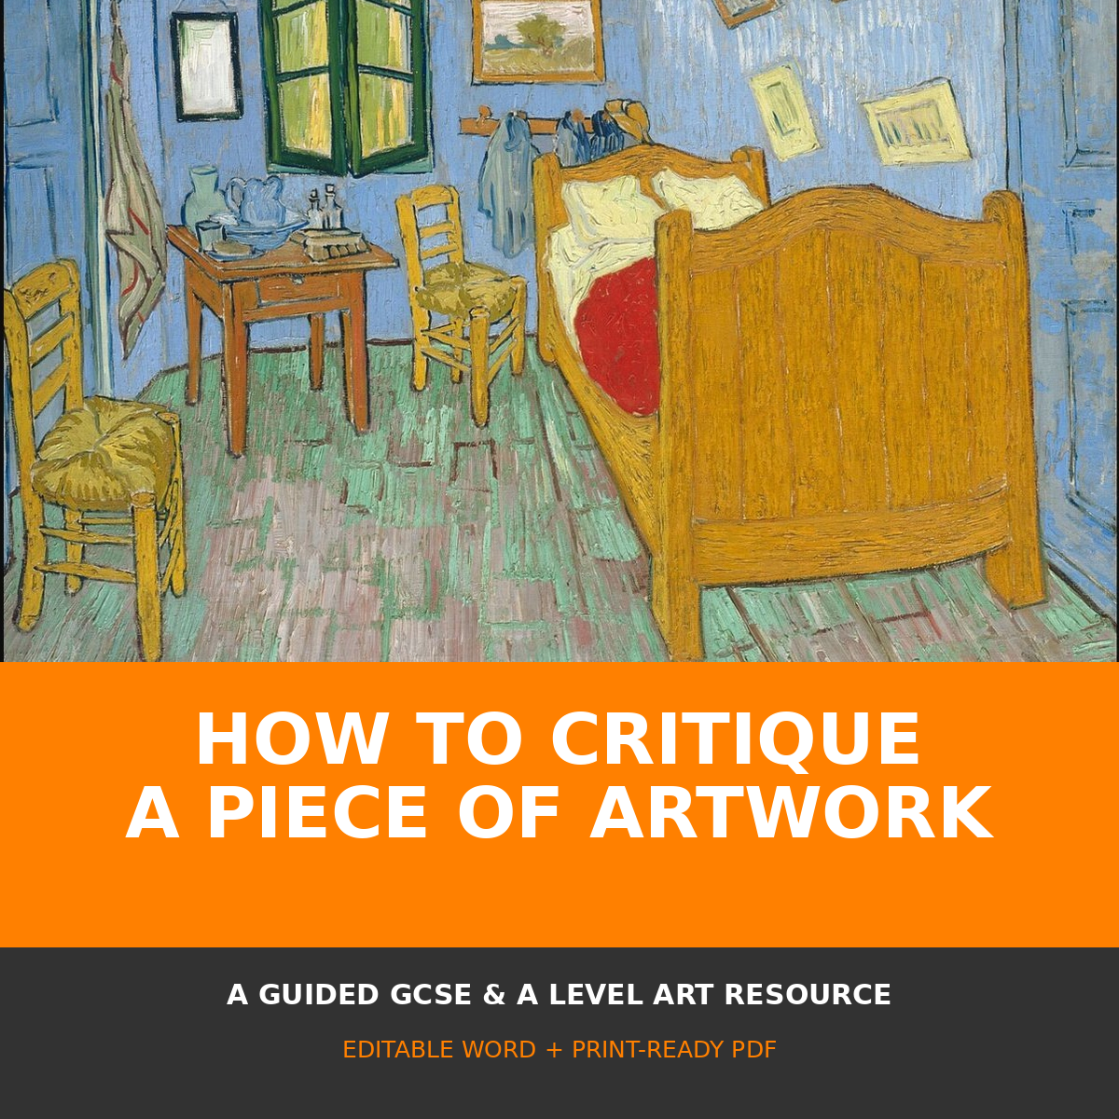
A structured 18-page resource using real public-domain artworks for a worked example and independent practice.
Editable Word document and print-ready PDF

How to use this pack

This pack teaches critique as a sequence of observable, evidence-based decisions rather than a list of unsupported opinions. It uses two genuine public-domain paintings: Vincent van Gogh’s The Bedroom for the worked example and Georges Seurat’s A Sunday on La Grande Jatte—1884 for independent practice.

Suggested teaching sequence
- Display the artwork without giving students contextual information. Allow one minute of silent looking.
- Separate factual description from analysis: students first identify what is visible, then explain how visual choices affect the viewer.
- Model one short evidence-based sentence before students use the planning grids.
- Compare interpretations and require students to point to visible evidence.
- Finish with a balanced judgement and one connection to the student’s own practical work.

Learning outcomes
- Use accurate visual vocabulary for composition, colour, tone, line, shape, space, texture and technique.
- Support interpretations and judgements with specific visual evidence.
- Distinguish description, analysis, interpretation, context and evaluation.
- Use contextual research carefully without allowing biography to replace looking.
- Apply one useful finding to a personal project or practical experiment.
IMPORTANT RIGHTS NOTE
Both embedded reproductions are identified as public-domain works on their Wikimedia Commons file pages. Full artwork details, source links and rights notes appear on page 18. Always retain those credits when adapting the editable file.

Six stages and eight guided steps

STEP | WHAT THE STUDENT DOES
1. LOOK | Pause before writing. Scan the whole image, then notice small details.
2. DESCRIBE | State what is visibly present without explaining or judging it.
3. ANALYSE | Explain how formal choices organise the image and direct attention.
4. INTERPRET | Suggest possible meanings or moods, supported by visual evidence.
5. CONTEXTUALISE | Use relevant artist, date, medium and context to deepen—not replace—looking.
6. JUDGE + CONNECT | Reach a balanced conclusion and identify a useful idea for your own work.
The eight guided steps that follow expand the Analyse and Interpret stages into focused pages on composition, colour, line, space, materials, technique, mood and meaning.

A strong critique keeps returning to evidence
CLAIM → EVIDENCE → EFFECT
Claim: the room feels unsettled. Evidence: the floorboards and furniture edges tilt towards different vanishing points. Effect: the space appears compressed and slightly unstable.

Avoid these shortcuts
- “I like it” without explaining why.
- Listing colours or objects without analysing their relationships.
- Assuming the artist’s intention without evidence.
- Retelling the artist’s biography instead of examining the artwork.
- Using confident terminology inaccurately. A precise simple sentence is better than vague jargon.

Visual language and sentence stems

AREA | USEFUL WORDS
Composition | placement, crop, focal point, balance, symmetry, asymmetry, rhythm, scale, viewpoint
Colour | hue, saturation, complementary, analogous, warm, cool, contrast, harmony, accent
Tone and light | value, highlight, mid-tone, shadow, contrast, direction, atmosphere
Line and shape | contour, directional, gestural, geometric, organic, repeated, angular, curved
Space and form | foreground, middle ground, background, overlap, depth, perspective, negative space
Surface and technique | texture, brushwork, mark, layering, transparency, impasto, blend, edge

Build evidence-based sentences
- The artist draws attention to ___ by…
- The repeated ___ creates a sense of…
- The contrast between ___ and ___ makes…
- Although the composition first appears ___, closer inspection shows…
- This interpretation is supported by…
- The medium matters because…
- A strength of the work is…; however…
- I could apply this by testing… in my own work.
GCSE SUPPORT
Choose one formal element, point to one precise area and complete: “The artist uses ___ in the ___, which makes the viewer ___.”
A LEVEL EXTENSION
Compare two plausible interpretations. Identify the visual evidence supporting each, then judge which is more convincing and why.

Worked example: first encounter

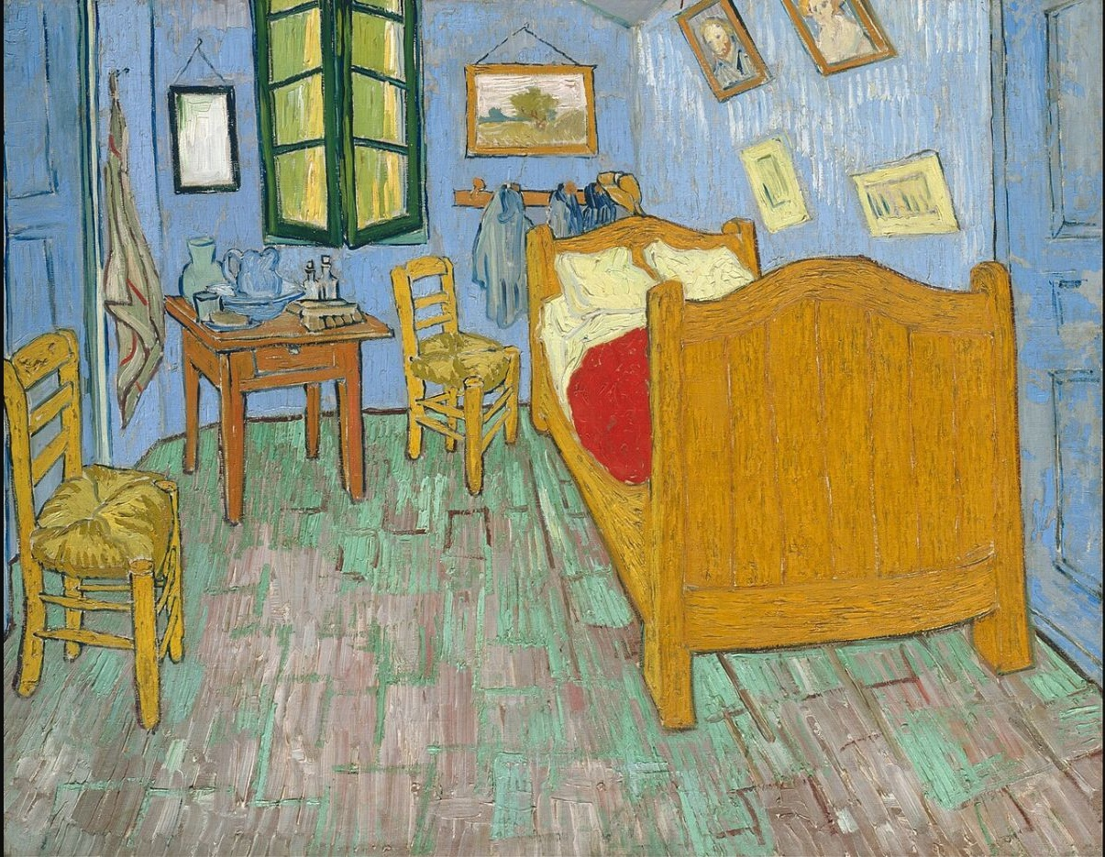
Vincent van Gogh, The Bedroom, 1889, oil on canvas, 73.6 × 92.3 cm, Art Institute of Chicago, accession 1926.417. Public-domain reproduction; source and rights details on page 18.

One minute of silent looking
Do not research yet. Let your eyes move around the image and record immediate observations without trying to sound sophisticated.
The first area I noticed was:
Three details I saw after looking for longer:
One question the artwork raises:
REMEMBER
An immediate response is a starting point, not a final interpretation. The next pages test it against visible evidence.

Step 1: describe what is visible

Description establishes shared evidence. Use neutral language and locate details precisely. Avoid “beautiful”, “strange” or “sad” at this stage because these are judgements or interpretations.

Model factual description
MODEL
A single bed occupies much of the right side. Two chairs sit at different depths. Blue walls surround a green-framed window, while small pictures hang at varied angles. Strong outlines separate objects and areas of colour.

Sort the statements
STATEMENT | TYPE
The bed fills much of the right foreground. | Description
The room feels private and isolated. | Interpretation
Blue and orange appear in strong contrast. | Analysis
The space was painted in 1889. | Context
The uneven perspective creates tension. | Analysis

Your factual inventory
Foreground:
Middle ground:
Background and edges:
Three repeated shapes or objects:

Step 2: analyse composition and viewpoint

Use a ruler or tracing sheet to follow the floorboards, bed edges and furniture angles.

What to examine
- Focal point: where does attention settle first, and what causes this?
- Directional lines: which edges pull the eye into or across the room?
- Scale and crop: how does the large bed affect the smaller furniture?
- Balance: compare the visual weight on the left and right.
- Viewpoint and perspective: do the lines create a stable or unsettled space?
MODEL ANALYSIS
The large orange-brown bed dominates the right foreground. Its diagonal edge pulls the viewer into the room, but the furniture and floorboards do not converge consistently. This compressed, uneven perspective makes an ordinary bedroom feel immediate and slightly unstable.
The viewer’s eye moves from ___ to ___ because:
The most important directional line is:
The composition feels balanced / unbalanced because:

Step 3: analyse colour, tone and contrast

Do more than name colours. Examine their temperature, saturation, placement and relationships. Consider whether colour describes observed reality, organises the composition or contributes to mood.
COLOUR / TONE | WHERE AND HOW | POSSIBLE EFFECT
Blue walls | Large cool field surrounding most objects | Makes orange-brown furniture appear warmer and more prominent
Orange-brown bed and chairs | Warm complementary contrast against blue | Creates unity while drawing attention to the furniture
Red bedding | Small saturated accent near the centre-right | Provides a sharp focal interruption
Green window and floor marks | Repeated cooler notes | Links separate areas and prevents a simple blue/orange split
Pale bedding and pictures | Lightest areas | Breaks the stronger colour fields and creates pauses

Test the interpretation
MODEL
The palette is limited but not quiet. Large blue areas surround warm orange-brown furniture, creating complementary contrast. The red blanket acts as a concentrated accent. These choices make the objects easy to distinguish while giving the room more visual energy than a naturalistic interior might have.
The strongest colour relationship is:
The lightest and darkest areas affect the focal point by:
If one colour changed, the mood might become:

Step 4: line, shape, form and space

Formal elements work together. A line may describe an edge, direct the eye and affect the sense of space at the same time.
ELEMENT | VISIBLE EVIDENCE | POSSIBLE EFFECT
Line | Strong dark contours; angled floorboards; repeated bed and chair edges | Separates objects and creates directional energy
Shape | Large bed rectangle; window panels; framed pictures; chair backs | Builds a pattern of repeated and tilted rectangles
Form | Colour changes and outlines suggest solid furniture without smooth modelling | Keeps forms clear and emphatic rather than illusionistically soft
Space | Overlap, scale and recession imply depth, but perspective is compressed | Places the viewer close to the room and disrupts calm stability
Negative space | Narrow gaps between furniture and walls | Makes the room appear occupied and enclosed

From observation to analysis
WEAK
There are lots of lines and shapes.
STRONGER
Repeated rectangular shapes appear in the bed, window and pictures, but many sit at different angles. Their repetition unifies the room while the tilted edges prevent it from feeling mechanically ordered.
One repeated shape and its effect:
One spatial distortion and its effect:
One relationship between line and mood:

Step 5: materials, technique and surface

The medium is not just a fact to copy from a label. Ask what oil paint allows the artist to do and how the visible handling of paint affects the experience of the room.
- Look for individual brushstrokes and changes in direction.
- Compare flat areas of colour with more broken or layered marks.
- Notice where outlines are thick, thin, repeated or incomplete.
- Identify hard and soft edges and how they separate forms.
- Consider how a reproduction may reduce the appearance of texture and scale.
MODEL ANALYSIS
Van Gogh uses visible directional brushstrokes rather than hiding the process of painting. Short marks follow the floorboards and furniture, while dark contours clarify object edges. The surface therefore records movement and decision-making; it does not behave like a polished photographic illusion.

Technique grid
VISIBLE FEATURE | LOCATION | EFFECT ON VIEWER
Directional brushwork
Dark outline
Broken colour
Hard or soft edge
The medium is important because:
I would need to inspect the original to understand:

Step 6: interpret mood and meaning

Interpretation is not guessing. Offer a possibility, then support it with several connected pieces of evidence. Different interpretations can be valid if they account for what is visible.
POSSIBLE READING | EVIDENCE TO TEST
Rest and simplicity | Single bed; limited furniture; clear separated objects; controlled palette
Energy or unease | Tilting pictures; inconsistent perspective; active brushwork; strong colour contrasts
Personal identity | Private room; selected possessions; portraits and everyday furniture
Enclosure or intimacy | Close viewpoint; large bed; narrow spaces between objects
BALANCED MODEL
The room can suggest both rest and unease. Its simple furniture and repeated blue create order, yet the tilted perspective and energetic brushwork disturb that calm. The tension between these qualities may be more convincing than describing the mood with a single word.

Build an interpretation
My possible interpretation is:
The first visual detail supporting it is:
A second, different detail supporting it is:
A competing interpretation could be:

Step 7: use context carefully

Context should sharpen visual analysis. Begin with the evidence in the artwork, consult reliable information, then explain how that information changes or qualifies your reading.

Verified object information
FIELD | DETAIL
Artist | Vincent van Gogh (1853–1890)
Title | The Bedroom
Date | 1889
Medium | Oil on canvas
Dimensions | 73.6 × 92.3 cm
Collection | Art Institute of Chicago; accession 1926.417

Museum interpretation to test
The Art Institute describes the work in relation to Van Gogh’s intention to suggest rest and repose, while noting the energetic handling and sharply receding space. Return to the image: which features support calm, and which complicate it?
CONTEXT SENTENCE FRAME
Knowing that ___ helps me notice ___. This strengthens / complicates my earlier interpretation because ___.
One contextual fact that genuinely changes my reading:
A visual detail that becomes more significant:
Information that is interesting but not necessary to this critique:

Step 8: reach a balanced judgement

A conclusion should evaluate how successfully the artwork’s visual choices work together. It may recognise tensions or limitations. Personal preference can be included, but it should not be the only basis for judgement.

Checklist for a convincing judgement
- Return to the central interpretation rather than introducing an unrelated idea.
- Identify at least one particularly effective formal choice.
- Acknowledge complexity, tension or a possible alternative reading.
- Refer to precise evidence rather than repeating general adjectives.
- Explain what the artwork helps you understand or reconsider.
MODEL JUDGEMENT
The painting is effective because its colour and simplified furniture make the room immediately legible, while the compressed perspective and visible brushwork keep the image emotionally unsettled. Rather than illustrating rest in a straightforward way, it makes calm feel actively constructed and fragile.

Your balanced conclusion
Overall, the work is effective / less effective because:
The strongest visual decision is:
A tension or limitation is:
The work changes my understanding of:

A model critique: bringing the stages together

Use the model to identify structure, not to memorise sentences. The most useful phrases are those that connect a claim to precise evidence and an effect.
Vincent van Gogh’s The Bedroom presents a private interior through simplified forms, strong outlines and large areas of colour. A wooden bed dominates the right foreground, while two chairs and a small table occupy the left and centre. This arrangement makes the space easy to read, but it is not conventionally stable. Bed edges, floorboards and furniture recede at different angles, compressing the room and placing the viewer unusually close to its contents.
Colour reinforces this mixture of clarity and tension. Cool blue walls surround warm orange-brown furniture, creating a complementary contrast that separates the major forms. The concentrated red of the bedding interrupts the larger colour fields and helps establish a focal point. Visible brushstrokes follow surfaces and edges, so the painting records the artist’s physical decisions rather than hiding them beneath a smooth illusion.
The room can therefore suggest both rest and unease. Its limited furnishings and repeated colours imply simplicity, yet tilted pictures, inconsistent perspective and active marks disturb complete calm. Context strengthens this reading: museum information connects the subject with Van Gogh’s wish to evoke repose, but the formal evidence makes that repose feel energetic and hard-won. The painting is compelling because these apparently opposing qualities remain in tension. It shows how an ordinary interior can communicate an emotional state without relying on a dramatic event.

Find the evidence
- Underline factual description once.
- Underline formal analysis twice.
- Circle the interpretation and balanced judgement.
- Draw arrows from two claims to the visual evidence supporting them.

Improve a weak critique

Rewrite each comment so it names a specific visual choice, locates evidence and explains an effect.
WEAK COMMENT | EVIDENCE-BASED START
I like the colours. | The contrast between ___ and ___ makes…
The composition is good. | The placement of ___ directs the eye towards…
It looks sad. | The mood may feel ___ because…
The artist uses texture. | Visible ___ marks in the ___ create…
The perspective is weird. | The receding lines appear ___, which causes…
Van Gogh was famous. | Relevant context helps explain ___ because…

Three levels of improvement
1 — NAME
Identify the formal element accurately.
2 — LOCATE
Point to a precise area, relationship or repeated feature.
3 — EXPLAIN
State how the choice affects attention, space, mood or meaning.
Rewrite one weak comment as a full claim–evidence–effect sentence:
Add a qualifying sentence beginning “However” or “Although”:
Connect the insight to a practical test you could make:

Independent critique: Seurat

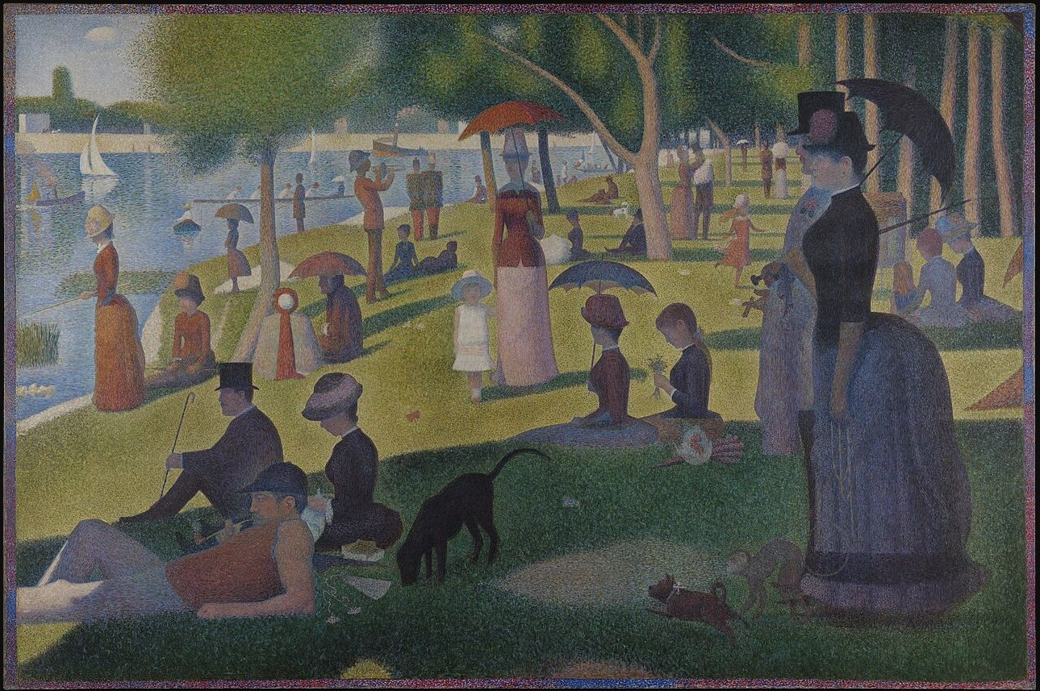
Georges Seurat, A Sunday on La Grande Jatte—1884, 1884–86, oil on canvas, 207.5 × 308.1 cm, Art Institute of Chicago, accession 1926.224. Public-domain reproduction; source and rights details on page 18.

First questions
- Where does your eye go first, and what creates that emphasis?
- How do repeated vertical figures and tree trunks organise the wide format?
- Compare the sunlit left area with the shaded foreground and right side.
- How do scale, overlap and the riverbank create depth?
- What mood is suggested by the still poses and repeated shapes?
- What can you infer from the surface of small colour touches?
First evidence-based observation:
A question requiring further looking or research:

Independent critique planning sheet

STAGE | NOTES AND EVIDENCE
Describe: subject, setting, objects
Composition and viewpoint
Colour, tone and light
Line, shape, form and space
Material, technique and texture
Mood, ideas and possible meanings
Relevant context
Balanced judgement
Connection to my own practical work

Paragraph structure
- Paragraph 1: identify the work and describe its most important visible features.
- Paragraph 2: analyse composition and the movement of the viewer’s eye.
- Paragraph 3: analyse colour, tone, line, space, surface and technique selectively.
- Paragraph 4: interpret meaning or mood and introduce only relevant context.
- Paragraph 5: reach a balanced judgement and connect one finding to your work.
SUCCESS CHECK
Every paragraph should contain at least one precise visual reference. Replace unsupported adjectives with claim–evidence–effect reasoning.

Teacher notes, artwork sources and permitted use

Artwork 1
Vincent van Gogh, The Bedroom, 1889, oil on canvas, 73.6 × 92.3 cm. Art Institute of Chicago, Helen Birch Bartlett Memorial Collection, accession 1926.417. Wikimedia Commons file: Vincent van Gogh - The Bedroom - Google Art Project.jpg. The file page identifies the original work and its faithful two-dimensional reproduction as public domain / Public Domain Mark 1.0.
https://commons.wikimedia.org/wiki/File:Vincent_van_Gogh_-_The_Bedroom_-_Google_Art_Project.jpg

Artwork 2
Georges Seurat, A Sunday on La Grande Jatte—1884, 1884–86, oil on canvas, 207.5 × 308.1 cm. Art Institute of Chicago, Helen Birch Bartlett Memorial Collection, accession 1926.224. Wikimedia Commons file: Georges Seurat - A Sunday on La Grande Jatte -- 1884 - Google Art Project.jpg. The file page identifies the artwork and faithful reproduction as public domain / Public Domain Mark 1.0.
https://commons.wikimedia.org/wiki/File:Georges_Seurat_-_A_Sunday_on_La_Grande_Jatte_--_1884_-_Google_Art_Project.jpg

Using public-domain images
- Retain the artist, title, date, collection and source details when adapting this document.
- Do not describe these artworks as student submissions, exam-board exemplars or work created by Portfolio to A Star.
- The artwork rights status does not remove the need for accurate attribution and respectful contextual teaching.
- Check a source page again before reusing a different scan, photograph or derivative image; rights information can differ by file.

Classroom use and copyright
The original teaching text, worksheets, layout and promotional graphics in this pack may be printed, edited and used with students within your own school, college or educational setting. They must not be sold, repackaged, uploaded to another website, shared publicly or distributed commercially. Copyright in the teaching resource remains with Portfolio to A Star and Ian Bradbury. The two embedded historical artworks remain public-domain works and are credited separately above.

Independent teaching material
This pack is independent teaching material and is not published or endorsed by AQA, OCR, Pearson Edexcel, WJEC or Eduqas. Consult the current specification for the course you teach.
More free GCSE and A Level Art and Design resources
https://portfoliotoastar.co.uk/free-resources-for-teachers/

