TEACHER RESOURCE 14

GCSE and A Level Art Cover Lessons
12 Ready to Print Independent Activities

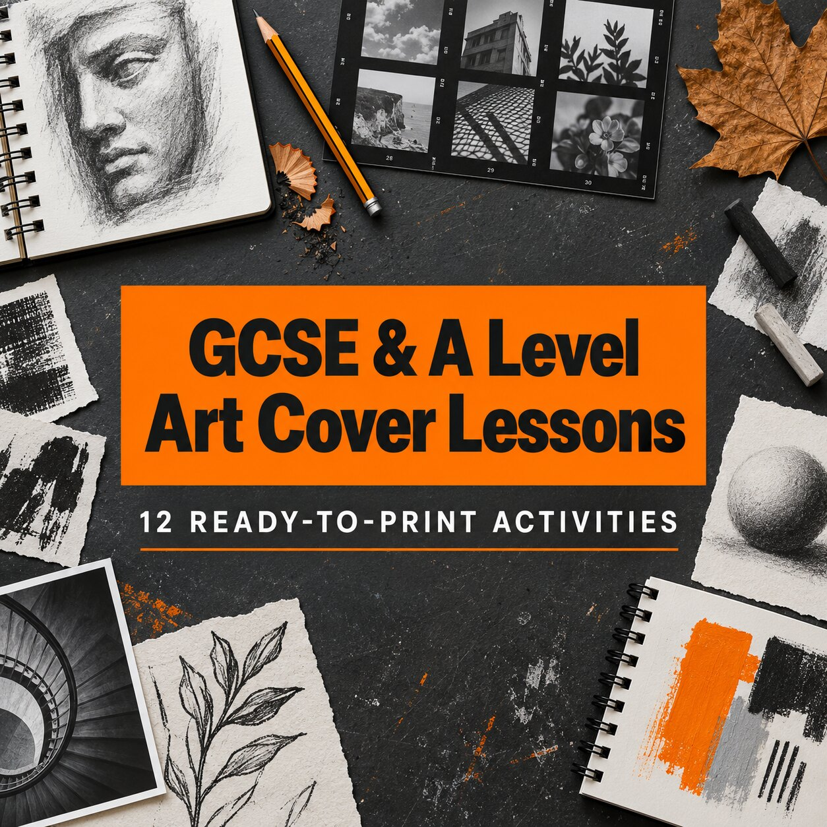
A printable cover-work pack for Fine Art, Photography and Graphic Communication. Each activity is designed for independent use in a 45–60 minute lesson with clear instructions, accessible support and an A Level extension.
Editable Word document and print-ready PDF

How to use this pack

This pack gives a cover teacher or supervising colleague twelve self-contained Art and Design activities. The tasks avoid specialist processes and can be completed from the printed sheet, using ordinary drawing materials or a school-approved camera where stated. Select the activity that best fits the class, print one copy per student and provide paper where extra working space is required.

Before the lesson
- Choose one activity and check the short materials list at the top of the page.
- Decide whether students will work directly on the sheet, in a sketchbook or on separate paper.
- Use the GCSE support or A Level extension selectively; students do not need to complete both.
- Remind students that quality, observation and decision-making matter more than filling every space.
- Collect the completed task or ask students to photograph it and place it beside their current project work.

For the cover teacher
Read the task aloud, point out the finish criteria and give a ten-minute warning before the final reflection. No specialist Art knowledge is required. Students should make their own visual decisions; the reference images are starting points rather than outcomes to copy mechanically.

Accessibility and differentiation
- Allow students to respond with labelled sketches, short phrases or recorded notes where appropriate.
- Reduce the number of required variations while keeping the comparison or reflection element.
- Enlarge the reference image or provide a digital copy for students who need it.
- Offer a limited choice of materials for GCSE support; ask A Level students to justify independent choices.

Assessment note
AO references indicate likely learning connections. They are not mark allocations and should not be used to award a grade from one isolated task.

Choose the right activity

NO. | ACTIVITY | PATHWAY | MAIN FOCUS | AO
01 | Crop and enlarge natural forms | Fine Art / all | Observation, composition | AO2, AO3
02 | Tone and cast shadow | Fine Art / all | Tone, form, light | AO2, AO3
03 | Positive and negative space | Fine Art / Graphics | Shape, balance | AO2, AO3
04 | Shape from shadow | Fine Art / Photography | Simplification, development | AO2, AO3
05 | Viewpoint and leading lines | Photography / all | Composition, viewpoint | AO2, AO3
06 | Contact sheet decisions | Photography | Selection, annotation | AO2, AO3
07 | Translate texture into marks | Fine Art / Graphics | Texture, mark-making | AO2, AO3
08 | Combine contrasting textures | Fine Art / Graphics | Surface, juxtaposition | AO2, AO4
09 | Transform an object into a symbol | Graphic Communication | Simplification, identity | AO2, AO4
10 | Build a packaging hierarchy | Graphic Communication | Layout, hierarchy | AO2, AO4
11 | Reflections and refractions | Photography / Fine Art | Light, distortion | AO2, AO3
12 | Three pathways from one image | All | Idea development | AO1–AO4

Quick selection guide
For a class needing calm observational work, choose 01, 02, 03 or 07. For a Photography group, choose 05, 06 or 11. For Graphic Communication, choose 09 or 10. To reconnect students with existing coursework, choose 12.

ACTIVITY 01

Crop and enlarge natural forms

TIME | MATERIALS | AO CONNECTIONS
50 minutes | Pencil, ruler, paper; optional coloured media | AO2 and AO3

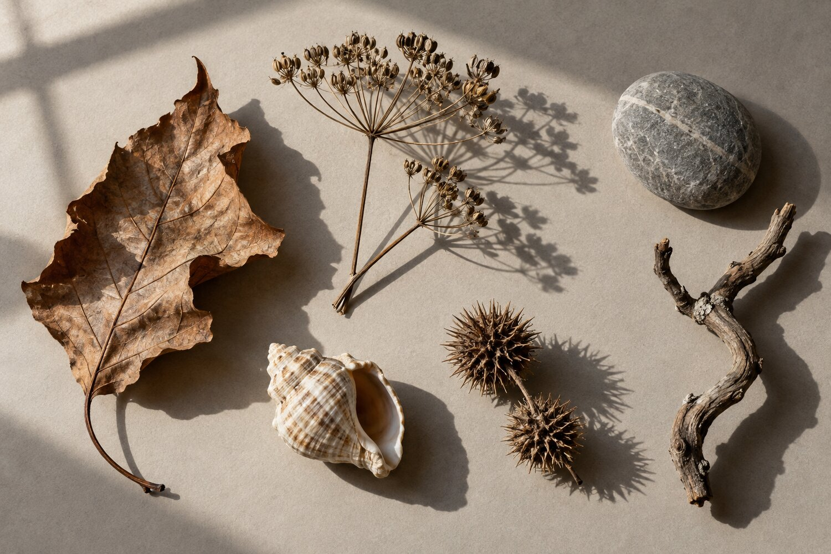
Original AI-generated teaching reference image for this activity; not student work.
Your task Choose one small area of the reference image and enlarge it so that the crop becomes a new composition. Do not draw every object.
- Use a viewfinder made from two L-shaped pieces of paper, or sketch three possible crops as rectangles.
- Select the crop with the strongest balance of shape, detail and empty space.
- Enlarge the chosen crop. Work from large shapes towards smaller observed details.
- Use at least three tones or one carefully controlled colour family.
GCSE SUPPORT | A LEVEL EXTENSION
Choose one object and use a teacher-provided crop. Mark the lightest, middle and darkest areas before drawing. | Create two contrasting crops: one descriptive and one nearly abstract. Explain which better suits a current project.
I selected this crop because…
My next improvement would be…

ACTIVITY 02

Tone and cast shadow

TIME | MATERIALS | AO CONNECTIONS
45–60 minutes | Graphite or charcoal, eraser, paper | AO2 and AO3

Original AI-generated teaching reference image for this activity; not student work.
Your task Produce a tonal study that makes the direction and strength of the light convincing. Treat the cast shadows as observed shapes.
- Identify the lightest highlight, darkest dark and three useful mid-tones.
- Block in the largest shadow shapes before adding outlines or fine detail.
- Compare the hard edge of one shadow with a softer edge elsewhere.
- Use the eraser as a drawing tool to recover highlights.
GCSE SUPPORT | A LEVEL EXTENSION
Work with one object only and create a five-box tonal scale before beginning. | Change the emotional effect through selective contrast. Keep evidence of one altered decision and annotate its effect.
The strongest tonal contrast is…
The light changes the mood by…

ACTIVITY 03

Positive and negative space

TIME | MATERIALS | AO CONNECTIONS
45 minutes | Black and white media, paper; optional scissors | AO2 and AO3

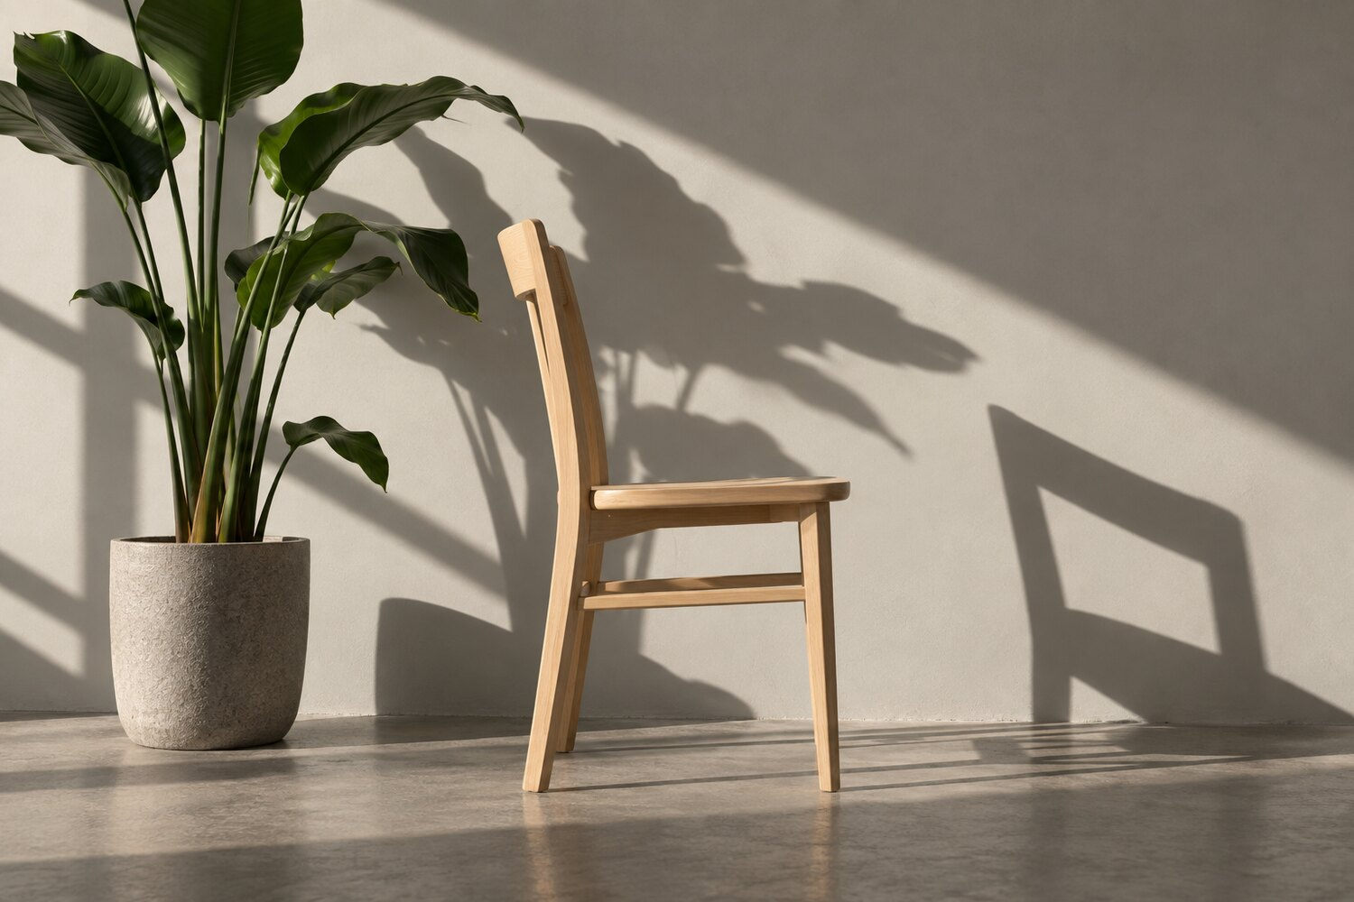
Original AI-generated teaching reference image for this activity; not student work.
Your task Simplify the chair, plant and surrounding gaps into a bold black-and-white composition. Give the empty spaces equal attention.
- Trace the main outer shapes with your eyes before drawing.
- Identify at least five negative spaces between or around the objects.
- Choose which shapes will be black and which will remain white.
- Adjust one shape to improve balance without losing the source.
GCSE SUPPORT | A LEVEL EXTENSION
Outline three negative spaces first, then add the objects around them. | Produce a second inversion in which black and white swap roles. Compare how the focal point changes.
The most important negative space is…
Changing this shape improved…

ACTIVITY 04

Shape from shadow

TIME | MATERIALS | AO CONNECTIONS
50 minutes | Pencil, black pen or collage paper | AO2 and AO3

Original AI-generated teaching reference image for this activity; not student work.
Your task Use the cast shadows—not the objects—as the starting point for a new abstract or semi-abstract design.
- Select three shadow shapes and simplify their edges.
- Rotate, overlap or repeat the shapes to make three thumbnail compositions.
- Choose one thumbnail and develop it at a larger scale.
- Introduce one controlled accent colour only if it strengthens the design.
GCSE SUPPORT | A LEVEL EXTENSION
Use two shadow shapes and repeat each one three times. | Develop the chosen composition for a specific purpose, such as a print, photographic projection or graphic background.
My composition creates movement by…
I would develop it through…

ACTIVITY 05

Viewpoint and leading lines

TIME | MATERIALS | AO CONNECTIONS
45–60 minutes | Pencil, pen and printed sheet; optional camera | AO2 and AO3

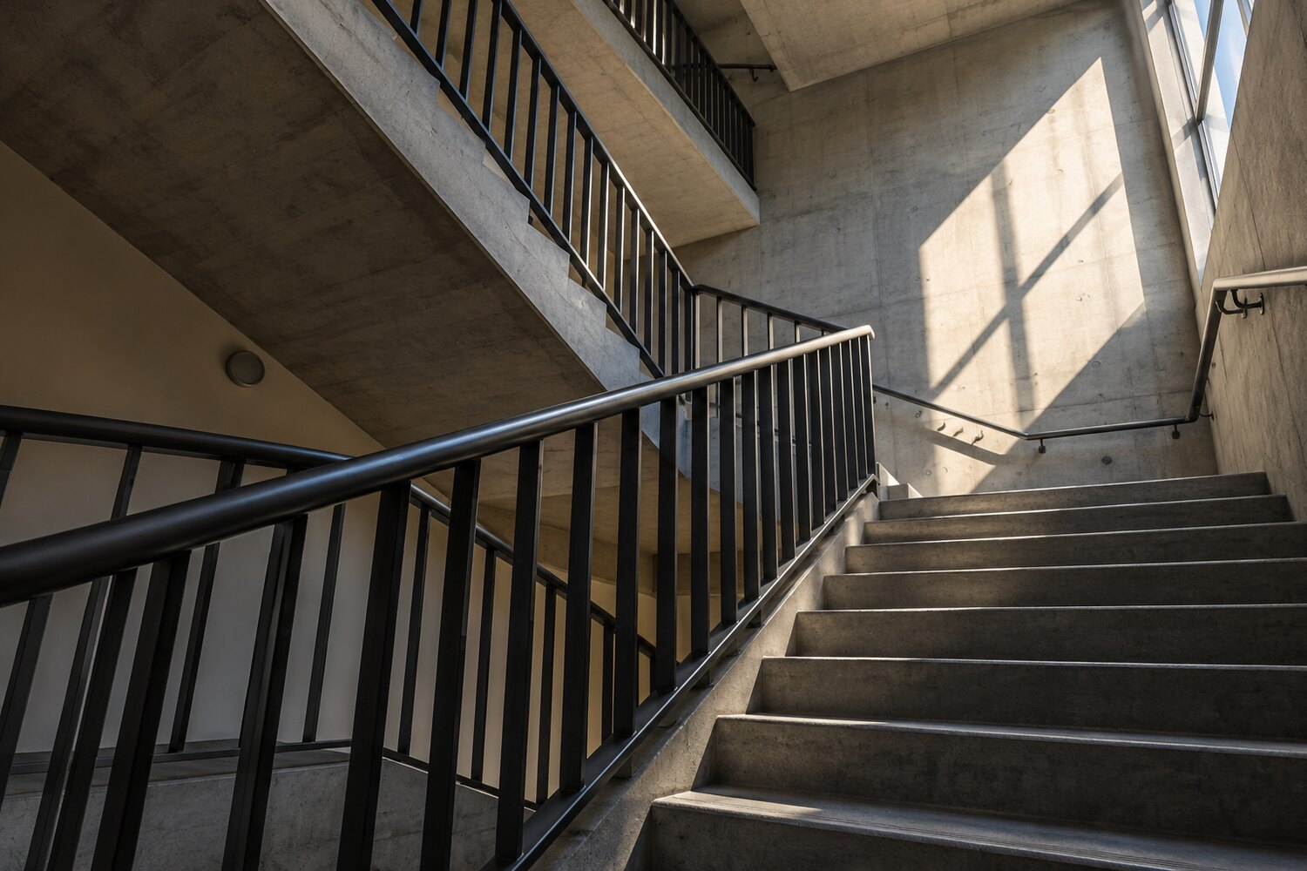
Original AI-generated teaching reference image for this activity; not student work.
Your task Investigate how viewpoint and leading lines direct attention through the architectural reference.
- Trace or sketch the three strongest directional lines.
- Mark the likely focal area and explain how the lines lead towards or away from it.
- Draw three thumbnail crops: low viewpoint, close detail and strongly asymmetrical.
- Develop the most purposeful composition as a drawing or photographic plan.
GCSE SUPPORT | A LEVEL EXTENSION
Use arrows to identify leading lines before making one thumbnail crop. | Challenge the obvious viewpoint. Plan a sequence of three images that changes scale, distance and visual tension.
The viewer’s eye moves…
My strongest viewpoint is… because…

ACTIVITY 06

Contact sheet decisions

TIME | MATERIALS | AO CONNECTIONS
50 minutes | Pencil, ruler; optional camera or phone | AO2 and AO3

Original AI-generated teaching reference image for this activity; not student work.
Your task Plan or make a six-image contact sheet exploring one location through purposeful variation rather than six similar photographs.
- Choose three variables from viewpoint, distance, orientation, focus, light and framing.
- Make six thumbnail frames or take six photographs, changing at least one variable each time.
- Circle the strongest two and identify visible evidence for each choice.
- State one precise change for a seventh image.
GCSE SUPPORT | A LEVEL EXTENSION
Use the printed reference to draw six different crops instead of taking photographs. | Order the six images as a sequence. Explain how repetition and change create a visual rhythm or narrative.
Image ___ is strongest because…
For image 7 I will change…

ACTIVITY 07

Translate texture into marks

TIME | MATERIALS | AO CONNECTIONS
45–60 minutes | Pencil, pen, charcoal; optional wax crayon | AO2 and AO3

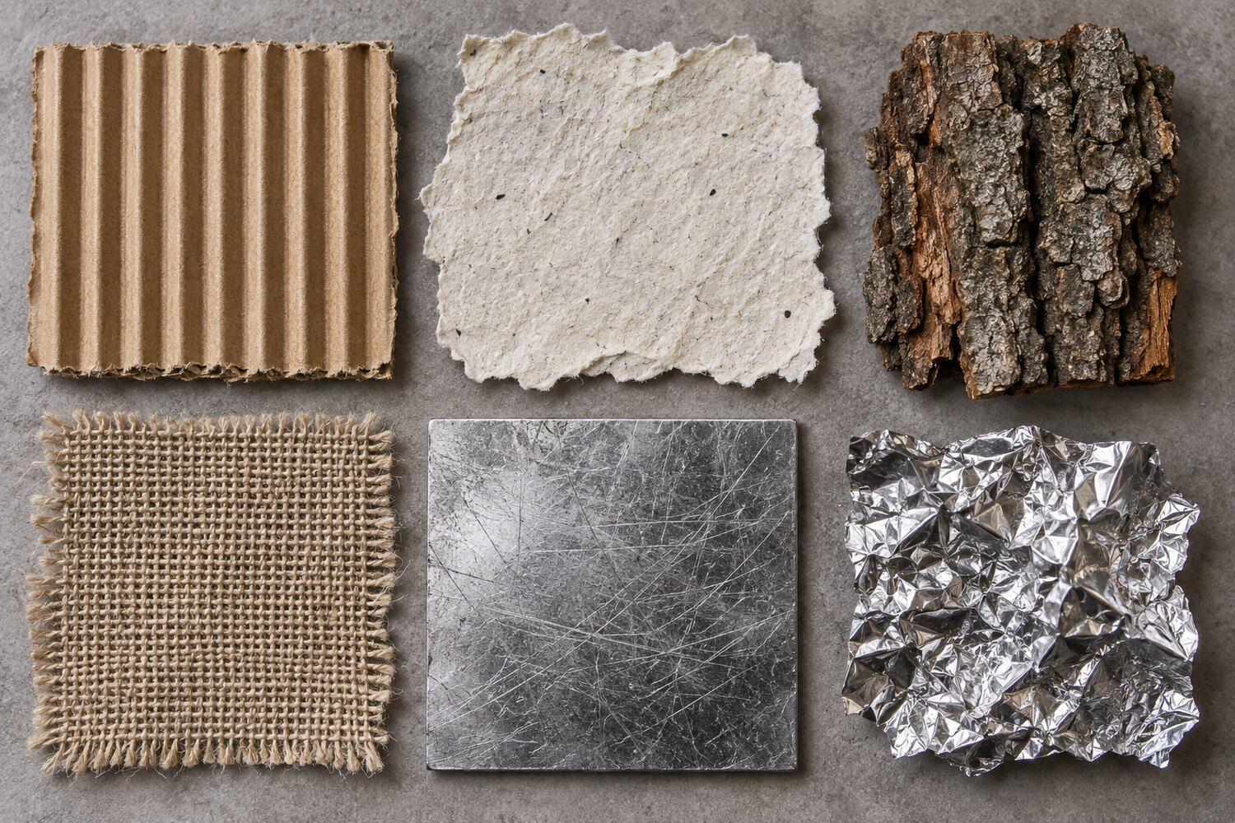
Original AI-generated teaching reference image for this activity; not student work.
Your task Invent a different family of drawn marks for each texture. Record surface qualities rather than outlining the sample.
- Select four textures and list two visual qualities for each.
- Test pressure, direction, density and tool angle in small rectangles.
- Choose the mark family that best communicates each surface.
- Arrange the four tests so the page moves from quiet to energetic.
GCSE SUPPORT | A LEVEL EXTENSION
Complete two textures using only line direction and pressure. | Translate one texture through two contrasting media and evaluate what each reveals or loses.
The most convincing mark is… because…
Changing pressure or density caused…

ACTIVITY 08

Combine contrasting textures

TIME | MATERIALS | AO CONNECTIONS
50 minutes | Drawing media, glue and found paper if available | AO2 and AO4

Original AI-generated teaching reference image for this activity; not student work.
Your task Combine two opposing textures to create a resolved small composition with a clear focal area.
- Choose one regular texture and one irregular texture.
- Make three thumbnails exploring overlap, separation and gradual transition.
- Develop one thumbnail using drawn, rubbed or collaged surface qualities.
- Refine the boundary where the two textures meet.
GCSE SUPPORT | A LEVEL EXTENSION
Use the pair cardboard and foil, and choose from overlap or separation. | Give the contrast a conceptual purpose such as natural/industrial, fragile/strong or order/disruption.
My two textures contrast because…
The focal area is created by…

ACTIVITY 09

Transform an object into a symbol

TIME | MATERIALS | AO CONNECTIONS
45–60 minutes | Pencil, black pen, tracing paper optional | AO2 and AO4

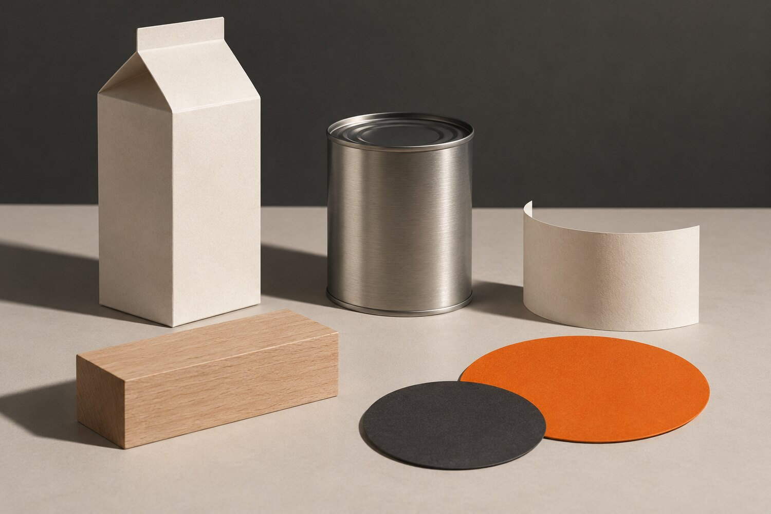
Original AI-generated teaching reference image for this activity; not student work.
Your task Choose one object and simplify it through stages until it becomes a distinctive graphic symbol.
- Draw the object as a simple silhouette.
- Remove unnecessary detail while retaining one recognisable feature.
- Create four variations by changing proportion, angle or positive/negative space.
- Select and refine the symbol that works best at both large and small scale.
GCSE SUPPORT | A LEVEL EXTENSION
Use the carton or tin and reduce it to no more than five shapes. | Combine the symbol with one letterform or geometric device. Test legibility at 20 mm wide.
The feature I retained was…
My symbol communicates…

ACTIVITY 10

Build a packaging hierarchy

TIME | MATERIALS | AO CONNECTIONS
50 minutes | Pencil, ruler, black pen; optional orange pencil | AO2 and AO4

Original AI-generated teaching reference image for this activity; not student work.
Your task Design the front of an imaginary package using hierarchy, alignment and controlled negative space. Do not copy existing branding.
- Invent a short product name of one or two words.
- Arrange a name, symbol and one short information line in three thumbnail layouts.
- Make the reading order obvious through scale and placement.
- Develop one layout on the blank carton shape or a drawn rectangle.
GCSE SUPPORT | A LEVEL EXTENSION
Use the supplied order: large product name, medium symbol, small information line. | Create a coherent front and side panel. Justify the grid, alignment and deliberate use of empty space.
The viewer should notice… first.
My layout feels unified because…

ACTIVITY 11

Reflections and refractions

TIME | MATERIALS | AO CONNECTIONS
45–60 minutes | Pencil or camera; optional black paper | AO2 and AO3

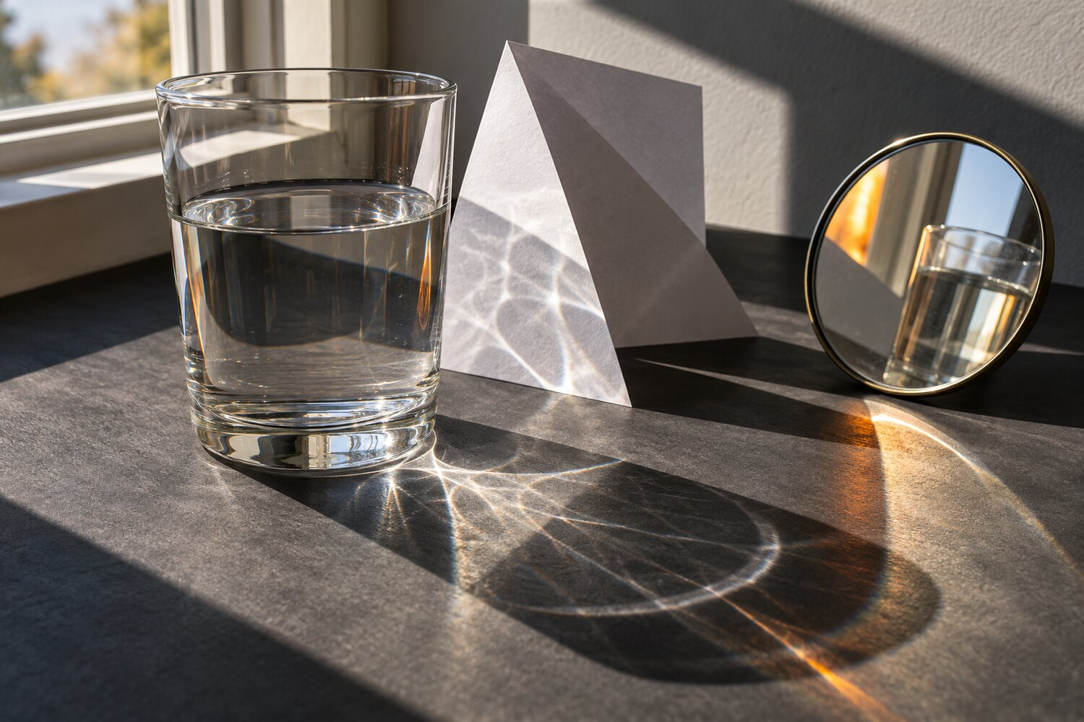
Original AI-generated teaching reference image for this activity; not student work.
Your task Explore how transparent and reflective surfaces distort what can be seen. Focus on observed edges, repeated shapes and light.
- Locate three places where an edge changes direction, doubles or disappears.
- Choose a crop containing reflection, refraction and shadow.
- Record the largest light and dark shapes before adding detail.
- Emphasise one distortion to make the outcome more visually purposeful.
GCSE SUPPORT | A LEVEL EXTENSION
Trace the crop as five large shapes, then add only the strongest reflected edge. | Make or plan a paired response: one analytical and one deliberately distorted. Explain which better extends an idea.
The most unexpected distortion is…
I emphasised it by…

ACTIVITY 12

Three pathways from one image

TIME | MATERIALS | AO CONNECTIONS
60 minutes | Any available dry media; optional camera | AO1 to AO4

Original AI-generated teaching reference image for this activity; not student work.
Your task Use one reference image to propose three genuinely different project pathways, then develop the most promising one.
- Pathway A: focus on a formal quality such as light, geometry or transparency.
- Pathway B: connect the image to a theme such as distortion, identity, fragility or repetition.
- Pathway C: translate it into another discipline—drawing, photography or graphic communication.
- Select one pathway and make a larger study plus a short next-step annotation.
GCSE SUPPORT | A LEVEL EXTENSION
Choose from the themes light, reflection or distortion and complete two pathways. | Add one relevant contextual direction without copying an artist. Explain how research could inform—not determine—the next experiment.
The pathway with most potential is… because…
My next practical test will…

Extension and differentiation planner

Use this page to adapt any activity without removing the central visual thinking. Change access, quantity or independence—not the expectation that students observe, make decisions and reflect.
NEED | USEFUL ADAPTATION | KEEP IN PLACE | POSSIBLE EVIDENCE
Needs a clearer start | Circle one starting area; provide a limited choice of two approaches. | A visible choice and comparison. | Thumbnail, crop or first test.
Finds writing difficult | Accept labels, sentence stems or a short recorded explanation. | The reason for a decision. | Labelled arrows or audio note.
Needs reduced quantity | Complete two strong variations rather than four rushed ones. | Evidence of change between trials. | Two compared outcomes.
Needs greater challenge | Remove the suggested material; require an independent constraint and justification. | Purposeful experimentation. | Plan, test and evaluation.
Finishes early | Develop the strongest result at a new scale, for a new purpose or through another discipline. | Connection to the first result. | Refinement plus annotation.
Missed prior teaching | Use the image and printed instructions as a self-contained starting point. | Observation before invention. | Completed reference response.

Your adaptation
Activity number and class:
Barrier or need identified:
Adaptation to provide:
Evidence students should produce:

Cover lesson record

This optional record helps the class teacher see what was attempted, what was completed and what needs following up. Avoid recording sensitive personal information on a sheet left with general cover work.
Class and date:
Activity used:
Cover teacher or supervisor:

Lesson overview
Students understood the task | Yes / Mostly / Some needed further explanation
Materials were available | Yes / Partly / No
Most students completed | All / Most / Part / Starting point only
Work was collected or stored | Collected / In sketchbooks / Photographed / Other
Follow-up is required | No / Yes — note below

What went well

Students or work requiring follow-up

Suggested next step for the class

Teacher notes and permitted use

About the visual references
All reference photographs and promotional artwork in this pack were created as original AI-generated teaching imagery for Portfolio to A Star. They are not student submissions, exam-board exemplars or evidence of a particular grade. Their purpose is to provide neutral visual starting points that can be printed and used without asking students to copy a named artist.

Using the activities responsibly
- Apply your school’s normal safeguarding and device-use policies when students take photographs.
- Check individual access arrangements and adapt the quantity or response method where appropriate.
- Use AO references as broad teaching connections rather than a substitute for the current specification or departmental assessment process.
- Encourage students to connect useful cover work to their own project rather than treating it as an isolated filler task.

Classroom use and copyright
This resource may be printed, edited and used with students within your own school, college or educational setting. It must not be sold, repackaged, uploaded to another website, shared publicly or distributed commercially. Copyright remains with Portfolio to A Star and Ian Bradbury.

Independent teaching material
This pack is independent teaching material and is not published or endorsed by AQA, OCR, Pearson Edexcel, WJEC or Eduqas. Teachers should consult the current specification and guidance for the course they deliver.
More free GCSE and A Level Art and Design resources
https://portfoliotoastar.co.uk/free-resources-for-teachers/

